## **Assignment: 03**

## **Step 1: Open Remix IDE**

1. Go to **Remix IDE** in your web browser.
2. Click **"Create New File"**.
3. Name your file as **HelloWorld.sol**.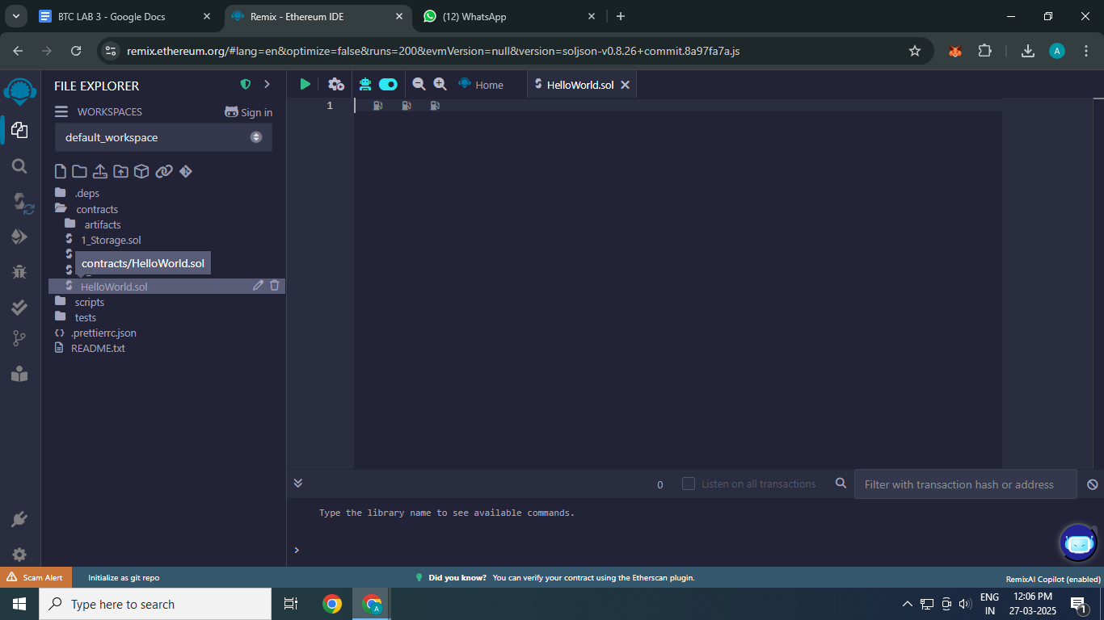

## **Step 2: Write a Hello World Smart Contract**

Solidity code:

// SPDX-License-Identifier: MIT

pragma solidity ^0.8.0;

contract HelloWorld {

string public message;

constructor() {

message = "BIA44 Aman Mujawar";

}

function getMessage() public view returns (string memory) {

return message;

}

function setMessage(string memory _newMessage) public {

message = _newMessage;

}

}

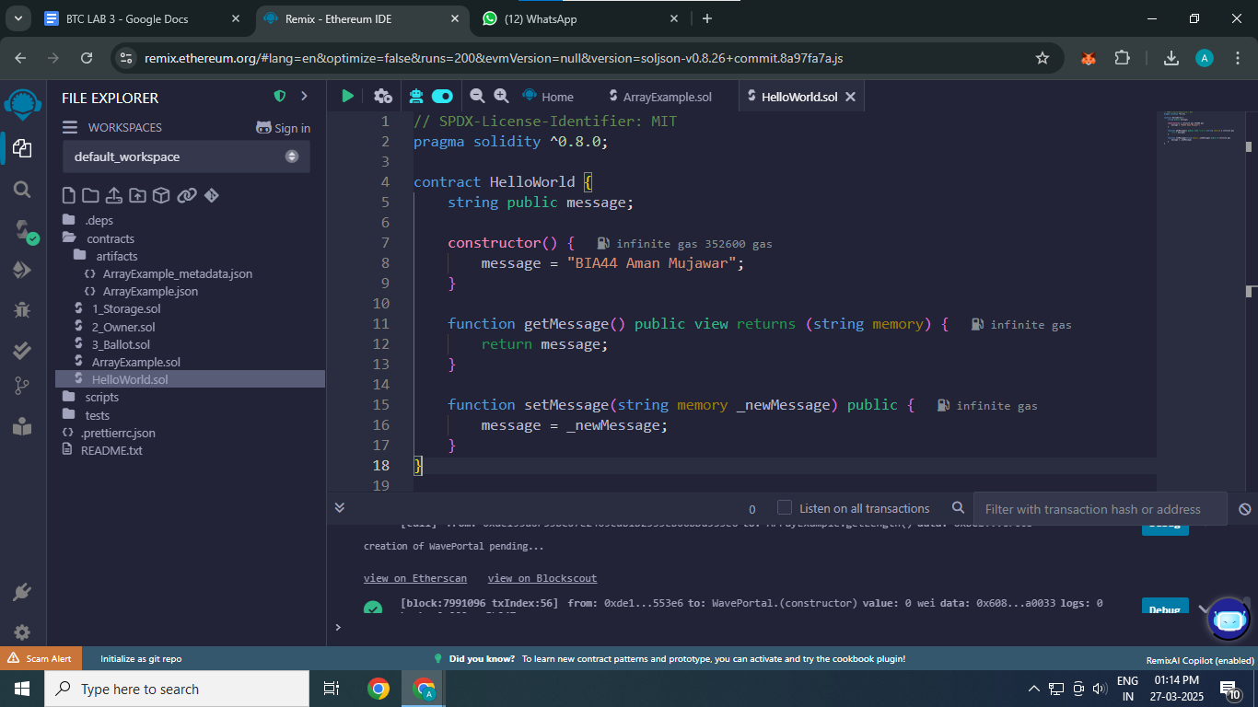

## **Step 3: Compile the Smart Contract**

1. Click on the **Solidity Compiler**.
2. Click the **"Compile HelloWorld.sol"** button.

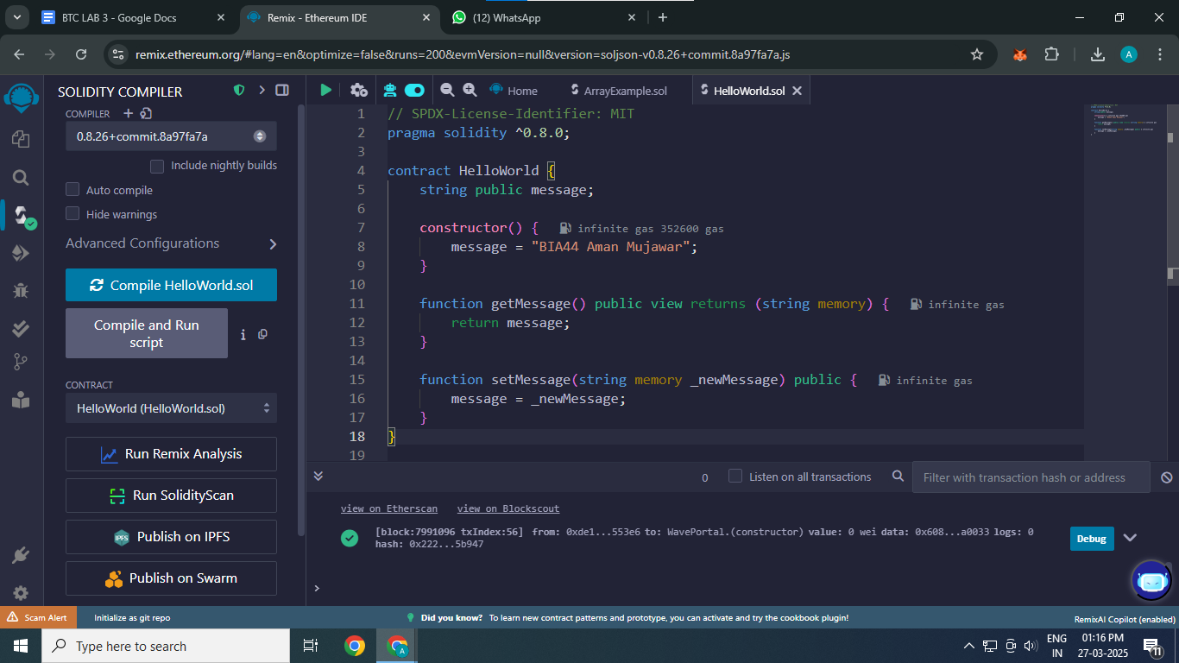

## **Step 4: Deploy the Smart Contract**

1. Click on the **Deploy & Run Transactions**
2. Under **"Environment"**, select **"Injected Provider(Meta Mask)"**.
3. 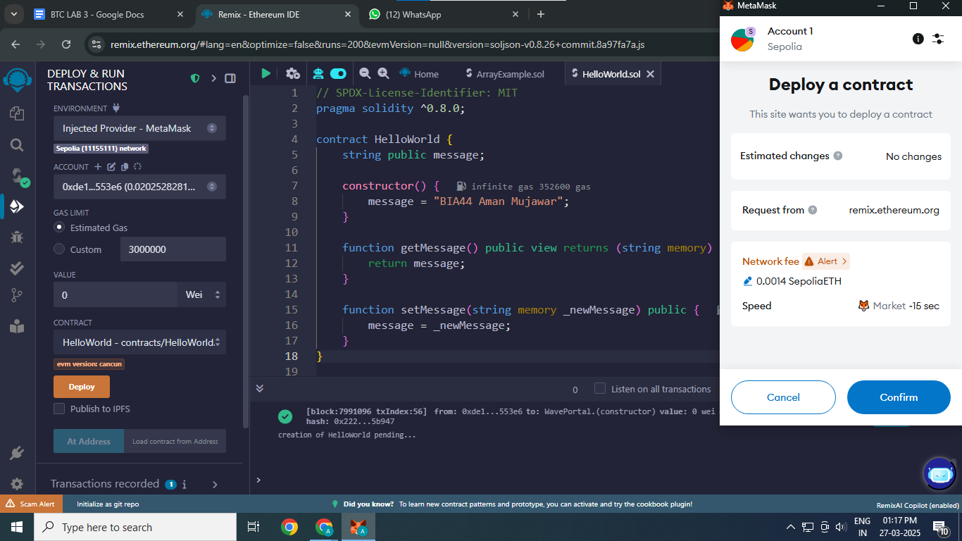Click **"Deploy"**.

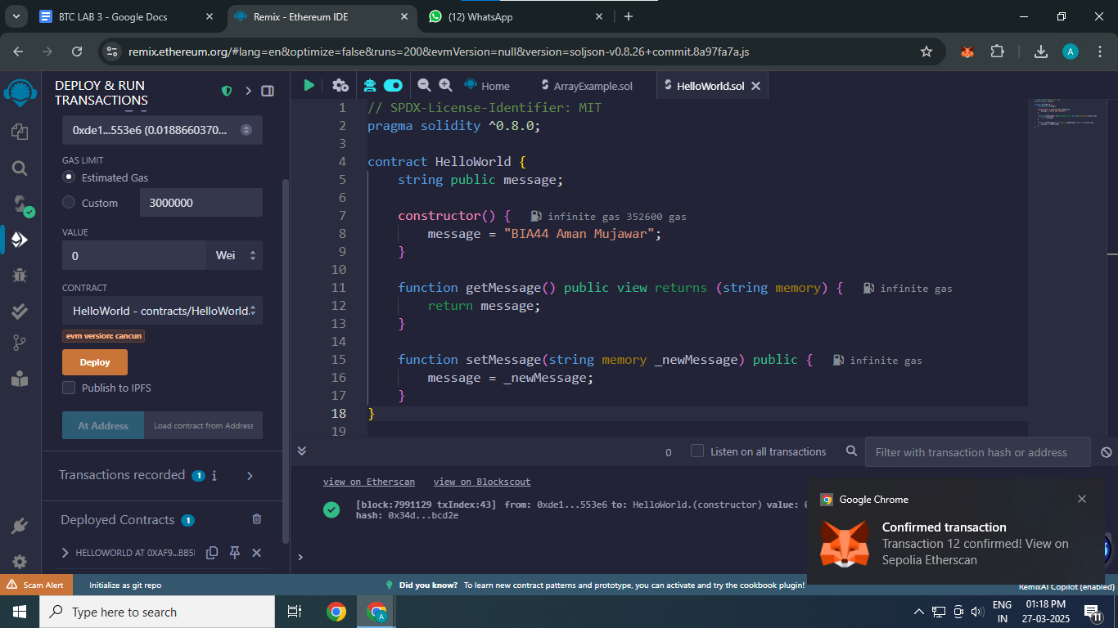

## **Step 5: Interact with the Smart Contract**

1. Click the **"getMessage"** function → It will return **"Hello, World!"**.
2. Click the **"setMessage"** function → Enter a new message, like "Welcome to Remix!" → Click **"Transact"**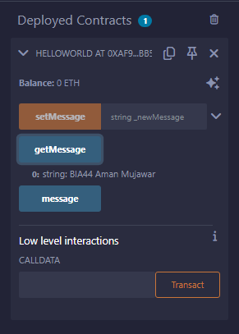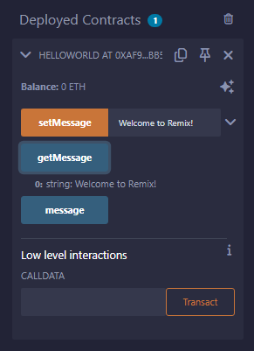.

**Step 6: Solidity example using Array**

1. Create another file named **ArrayExample.sol**.

Solidity code:

// SPDX-License-Identifier: MIT

pragma solidity ^0.8.0;

contract ArrayExample {

uint[] public numbers;

function addNumber(uint _num) public {

numbers.push(_num);

}

function getNumber(uint _index) public view returns (uint) {

require(_index < numbers.length, "Index out of range");

return numbers[_index];

}

function getAllNumbers() public view returns (uint[] memory) {

return numbers;

}

function getLength() public view returns (uint) {

return numbers.length;

}

}

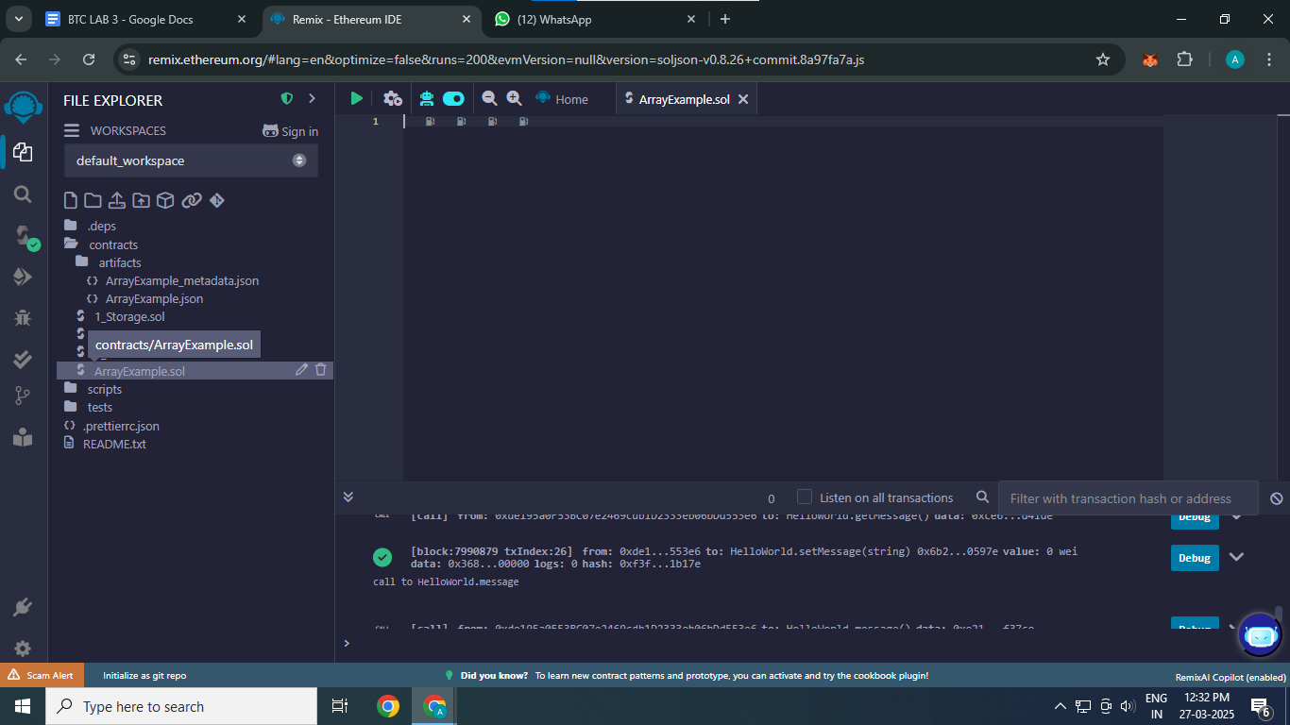

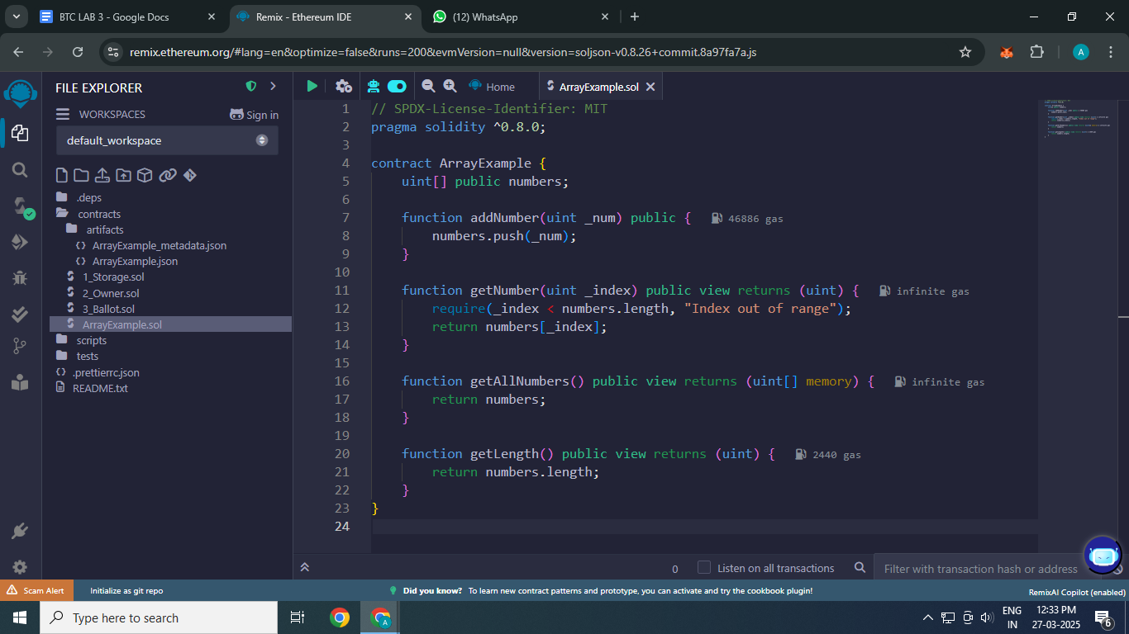

**Step 7: Compile and Deploy the ArrayExample Contract**

1. Click on the **Solidity Compiler**.
2. Compile **ArrayExample.sol**.

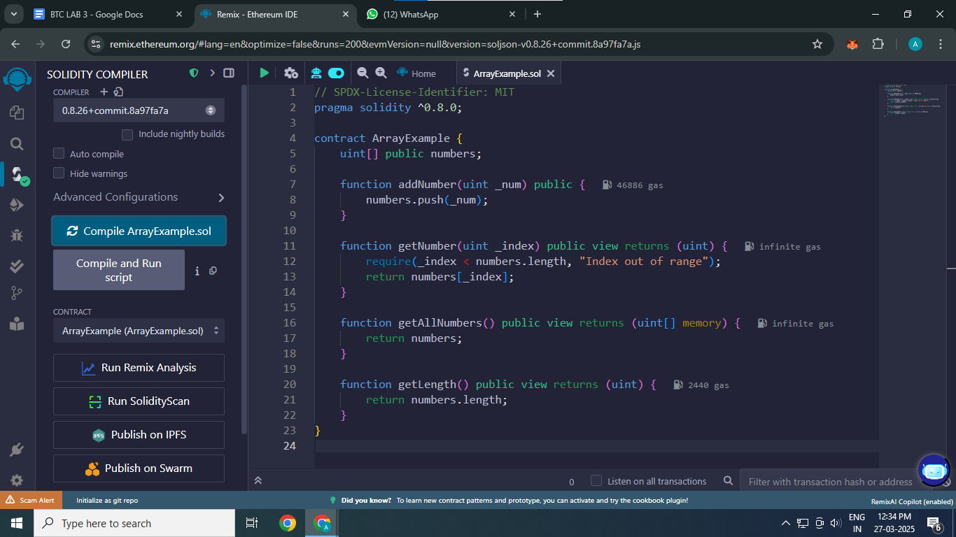

1. Click on the **Deploy & Run Transactions**.
2. 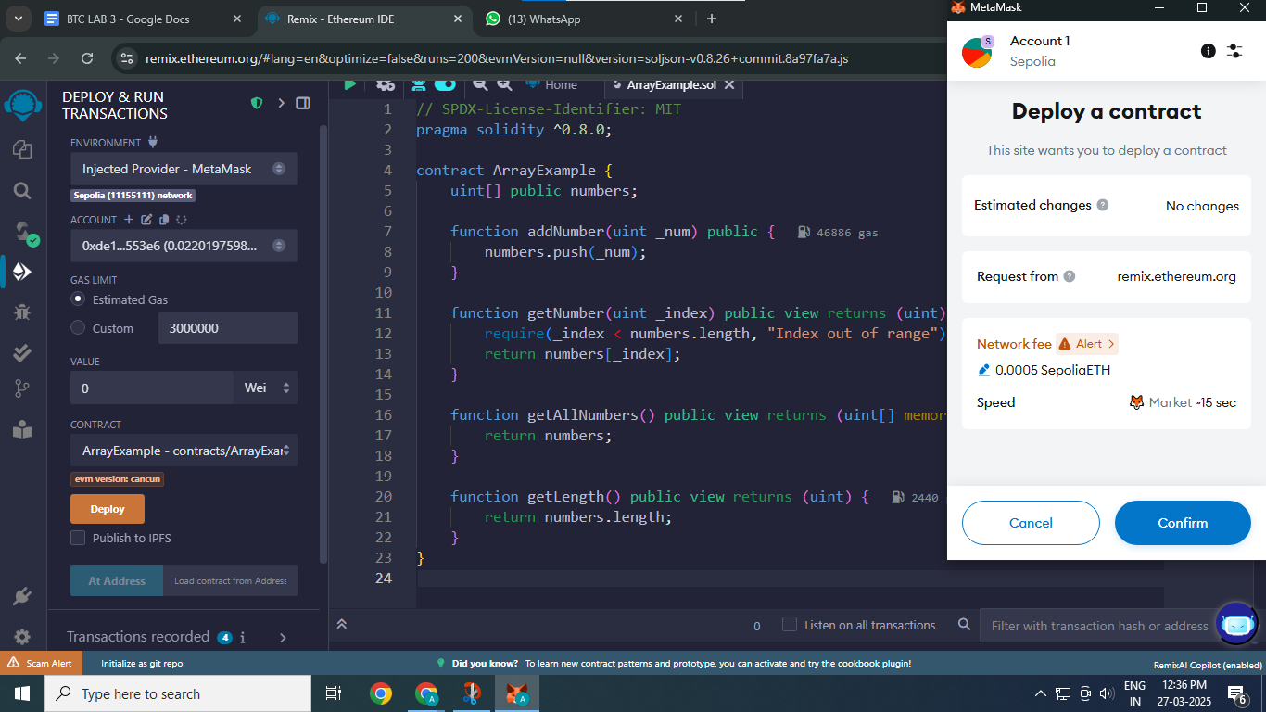Deploy the contract.

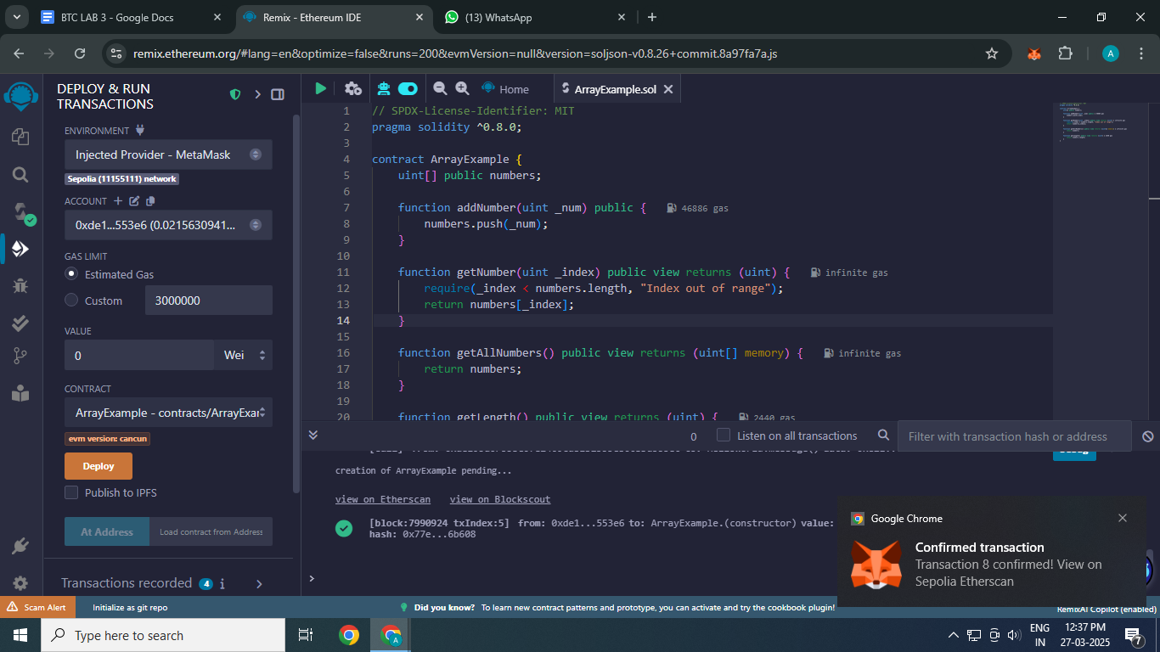

1. Interact with the contract:  
   